3rd Quarter Return
The 3rd Quarter return has been completed and will be forwarded to the local authority before the due date, 31/01/2022.
The present outturn figures are in excess of the agreed 5% threshold (currently 13.44% which equates to £399,165.00). The reason for this is as follows:
- Due to the expansion programme and the local authority placing a hold on revenue and capital expenditure on premises. This therefore encompassed our planned expenditure for the alarm system and the internal upgrade of internal LED lighting. Further details are included below in the Expansion section
- Additional Covid funding which is documented below:
COVID 19 catch up | £11,700
COVID Mass Testing | £48,340
COVID Workforce | £1,772
COVID Recovery Premium | £3,698
COVID School Led Tutoring | £4,781
TOTAL | £70,291.00

Russell has spoken with the local authority, who in principle have agreed, due to our planned expansion programme, for our carry forward to be in excess of the 5% threshold. Written agreement will need to be sought and our case presented to the local authority’s panel for agreement. This written request/template must accompany the 3rd Quarter return when submitted to the local authority by the end of the month.

There are a number of well-founded reasons to support our case, which are detailed below within the section regarding Expansion, but it remains the local authority’s approval for the funds not to be clawed back.
Household Support Grant – Winter Clothing
A grant application was made and we were awarded £1,600.00. This can be used to purchase winter clothing for any pupils we identify as in need. Receipts have to be submitted to the local authority as confirmation of purchase. How we utilise this money has yet to be agreed.
Household Support Grant
A grant application was made to the local authority for the above scheme for £800.00. The purpose of this grant was to ‘top up’ the schools Food Bank. Christmas tote bags were ordered and an order placed with Asda for non-perishable goods to the value of £800.00.
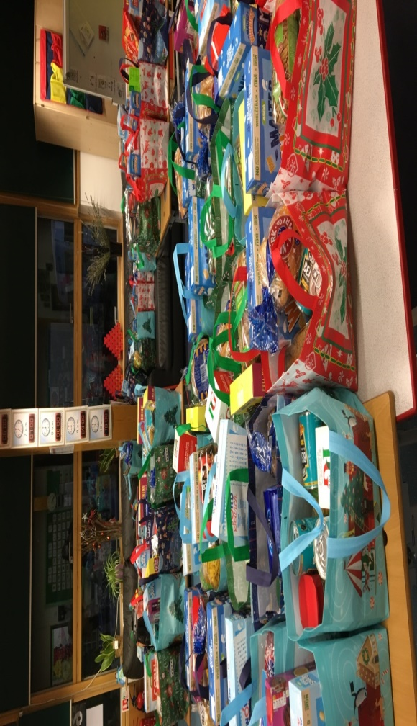
Once received the 6th Form were asked to help make 88 hampers which were distributed to all FSM pupils as well as those pupils identified whom would benefit.

The Hampers!

Minibuses
Four quotations have been received for new minibuses which do not require D1 licences. Quotations range from £49,995.00 to £52,626.00.
The specifications have been carefully examined to ensure the buses meet all the school requirements, receive best value and are purchased under the local authority procurement rules. One of the minibuses proposed provides space for up to 4 wheelchair users with removal of standard seats, which currently is something we are unable to provide. This is a Ford 14 seater £49,995.00, the second bus is a Vauxhall 17 seater, both have external underfloor lifts.
Premises
Unfortunately the school continues to show positive results for legionella although the count has reduced. Daily flushing continues and we are waiting for a further sample test to be taken and sent to the laboratory.
Audit & Risk Management
The school has now received its visit from Audit Risk Management to undertake their inspection of our cash handling and schools inventory system.
The visit went well and we were able to ‘show off’ our new digital version of Inventry which the auditor had not seen in any other school. We await feedback from the visit.

Expansion Programme
On Friday 21st January an expansion Programme meeting was held with the Project Manager, Director and an architect from BHP Architects, Russell, Louis and myself.
The proposed plans were discussed and various ideas/concerns considered.
The school unfortunately will loose the present bike court and as felt it’s an important hard core surface area for our pupils, we discussed the possibility of a bike track/walkway being constructed around the perimeter of the field. It was agreed this was a worthy idea, however something the school would have to finance.
Also due to the school lacking large spaces for groups to use, we have looked into the school erecting a dome structure over the present astro turf to enable PE to use all year round and create a covered space for drama and other outdoor events. Once again this is something the school would have to finance.
Areas which were discussed which will require the school to contribute financially and requested by the Project Manager to retain funds for these specific purposes are detailed below. These figures will be used to support our application to the local authority regarding retaining balances above the threshold:
Large Span Timber Canopy £99,835.00
Bike Track/Footpath with Road Signage £60,000.00
Internal LED Lighting £25,000.00
Telephone System £20,000.00
IT Equipment £15,000.00
Furniture and Fittings £20,000.00
TOTAL £239,835.00

