Oaktree School

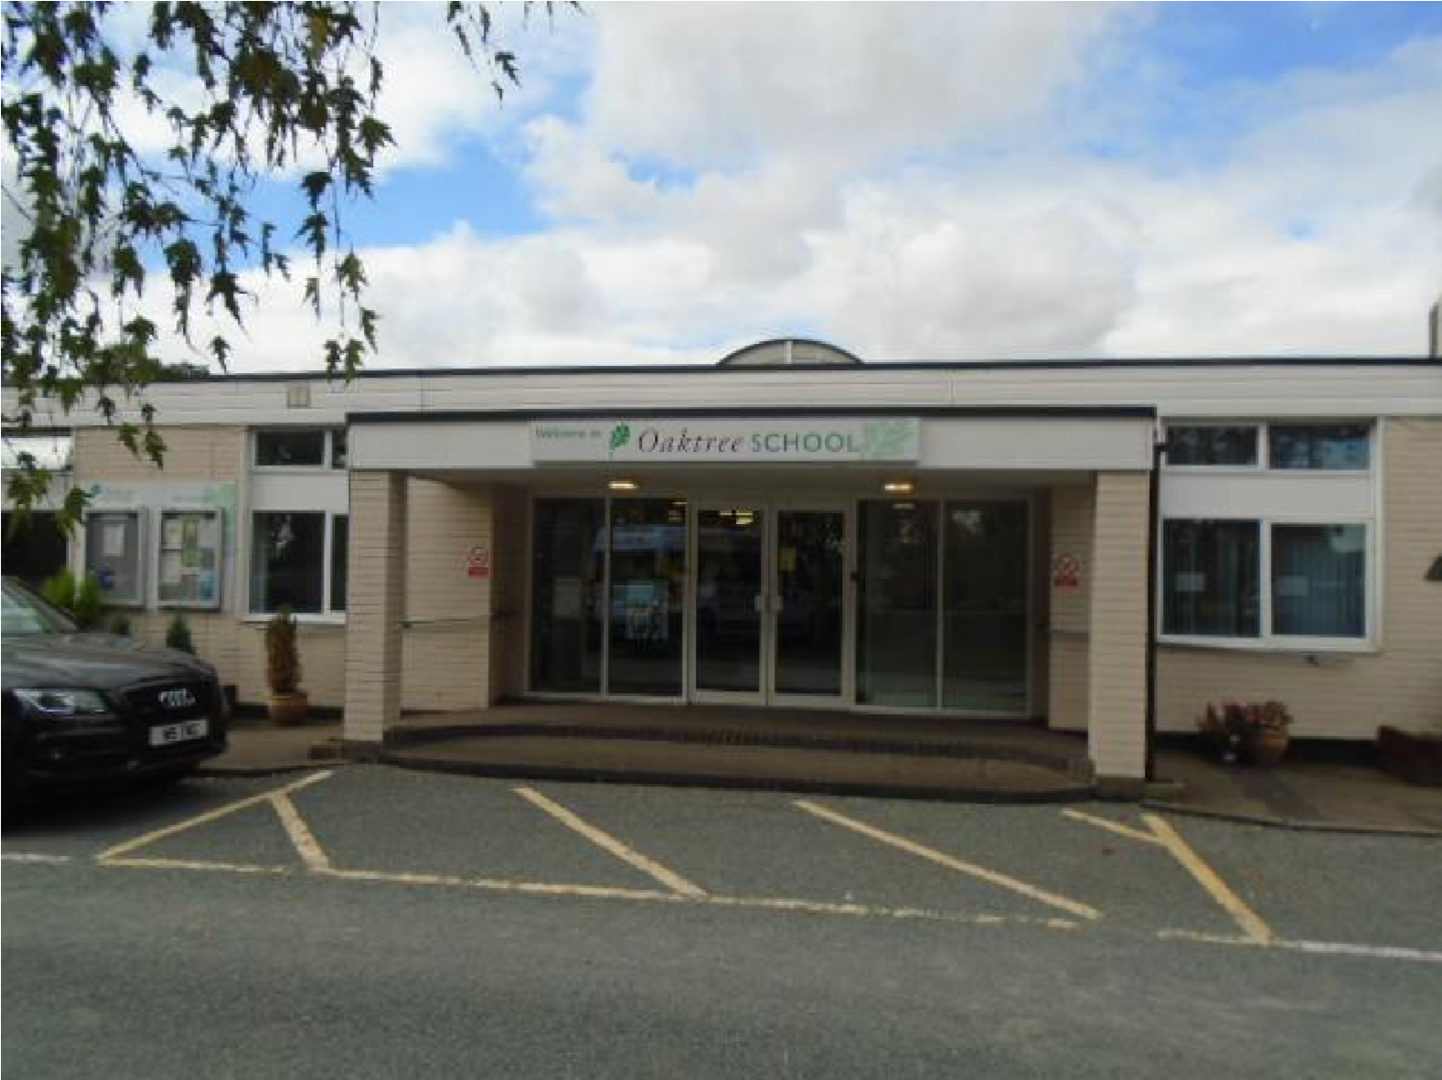

Sixth Form
Information Brochure
2021-2022

Oaktree School
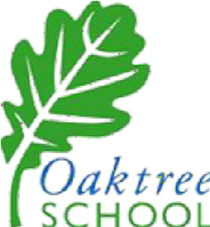
Chaseside
Southgate London N14 4HN Tel: 0208 440 3311 info@oaktree.enfield.sch.uk

Welcome to Oaktree School Sixth Form

The Sixth Form at Oaktree School is a very important place to be. Not only are our Sixth Formers role models to the younger students showing how to behave in all aspects of school life, but it is also a time for preparing to move on to the challenges beyond school.

Time in the Sixth Form therefore is a mixture of academic studies, learning to be independent, work experience opportunities, independent travel training, Enterprise projects and helping out as Monitors and Prefects around the school.

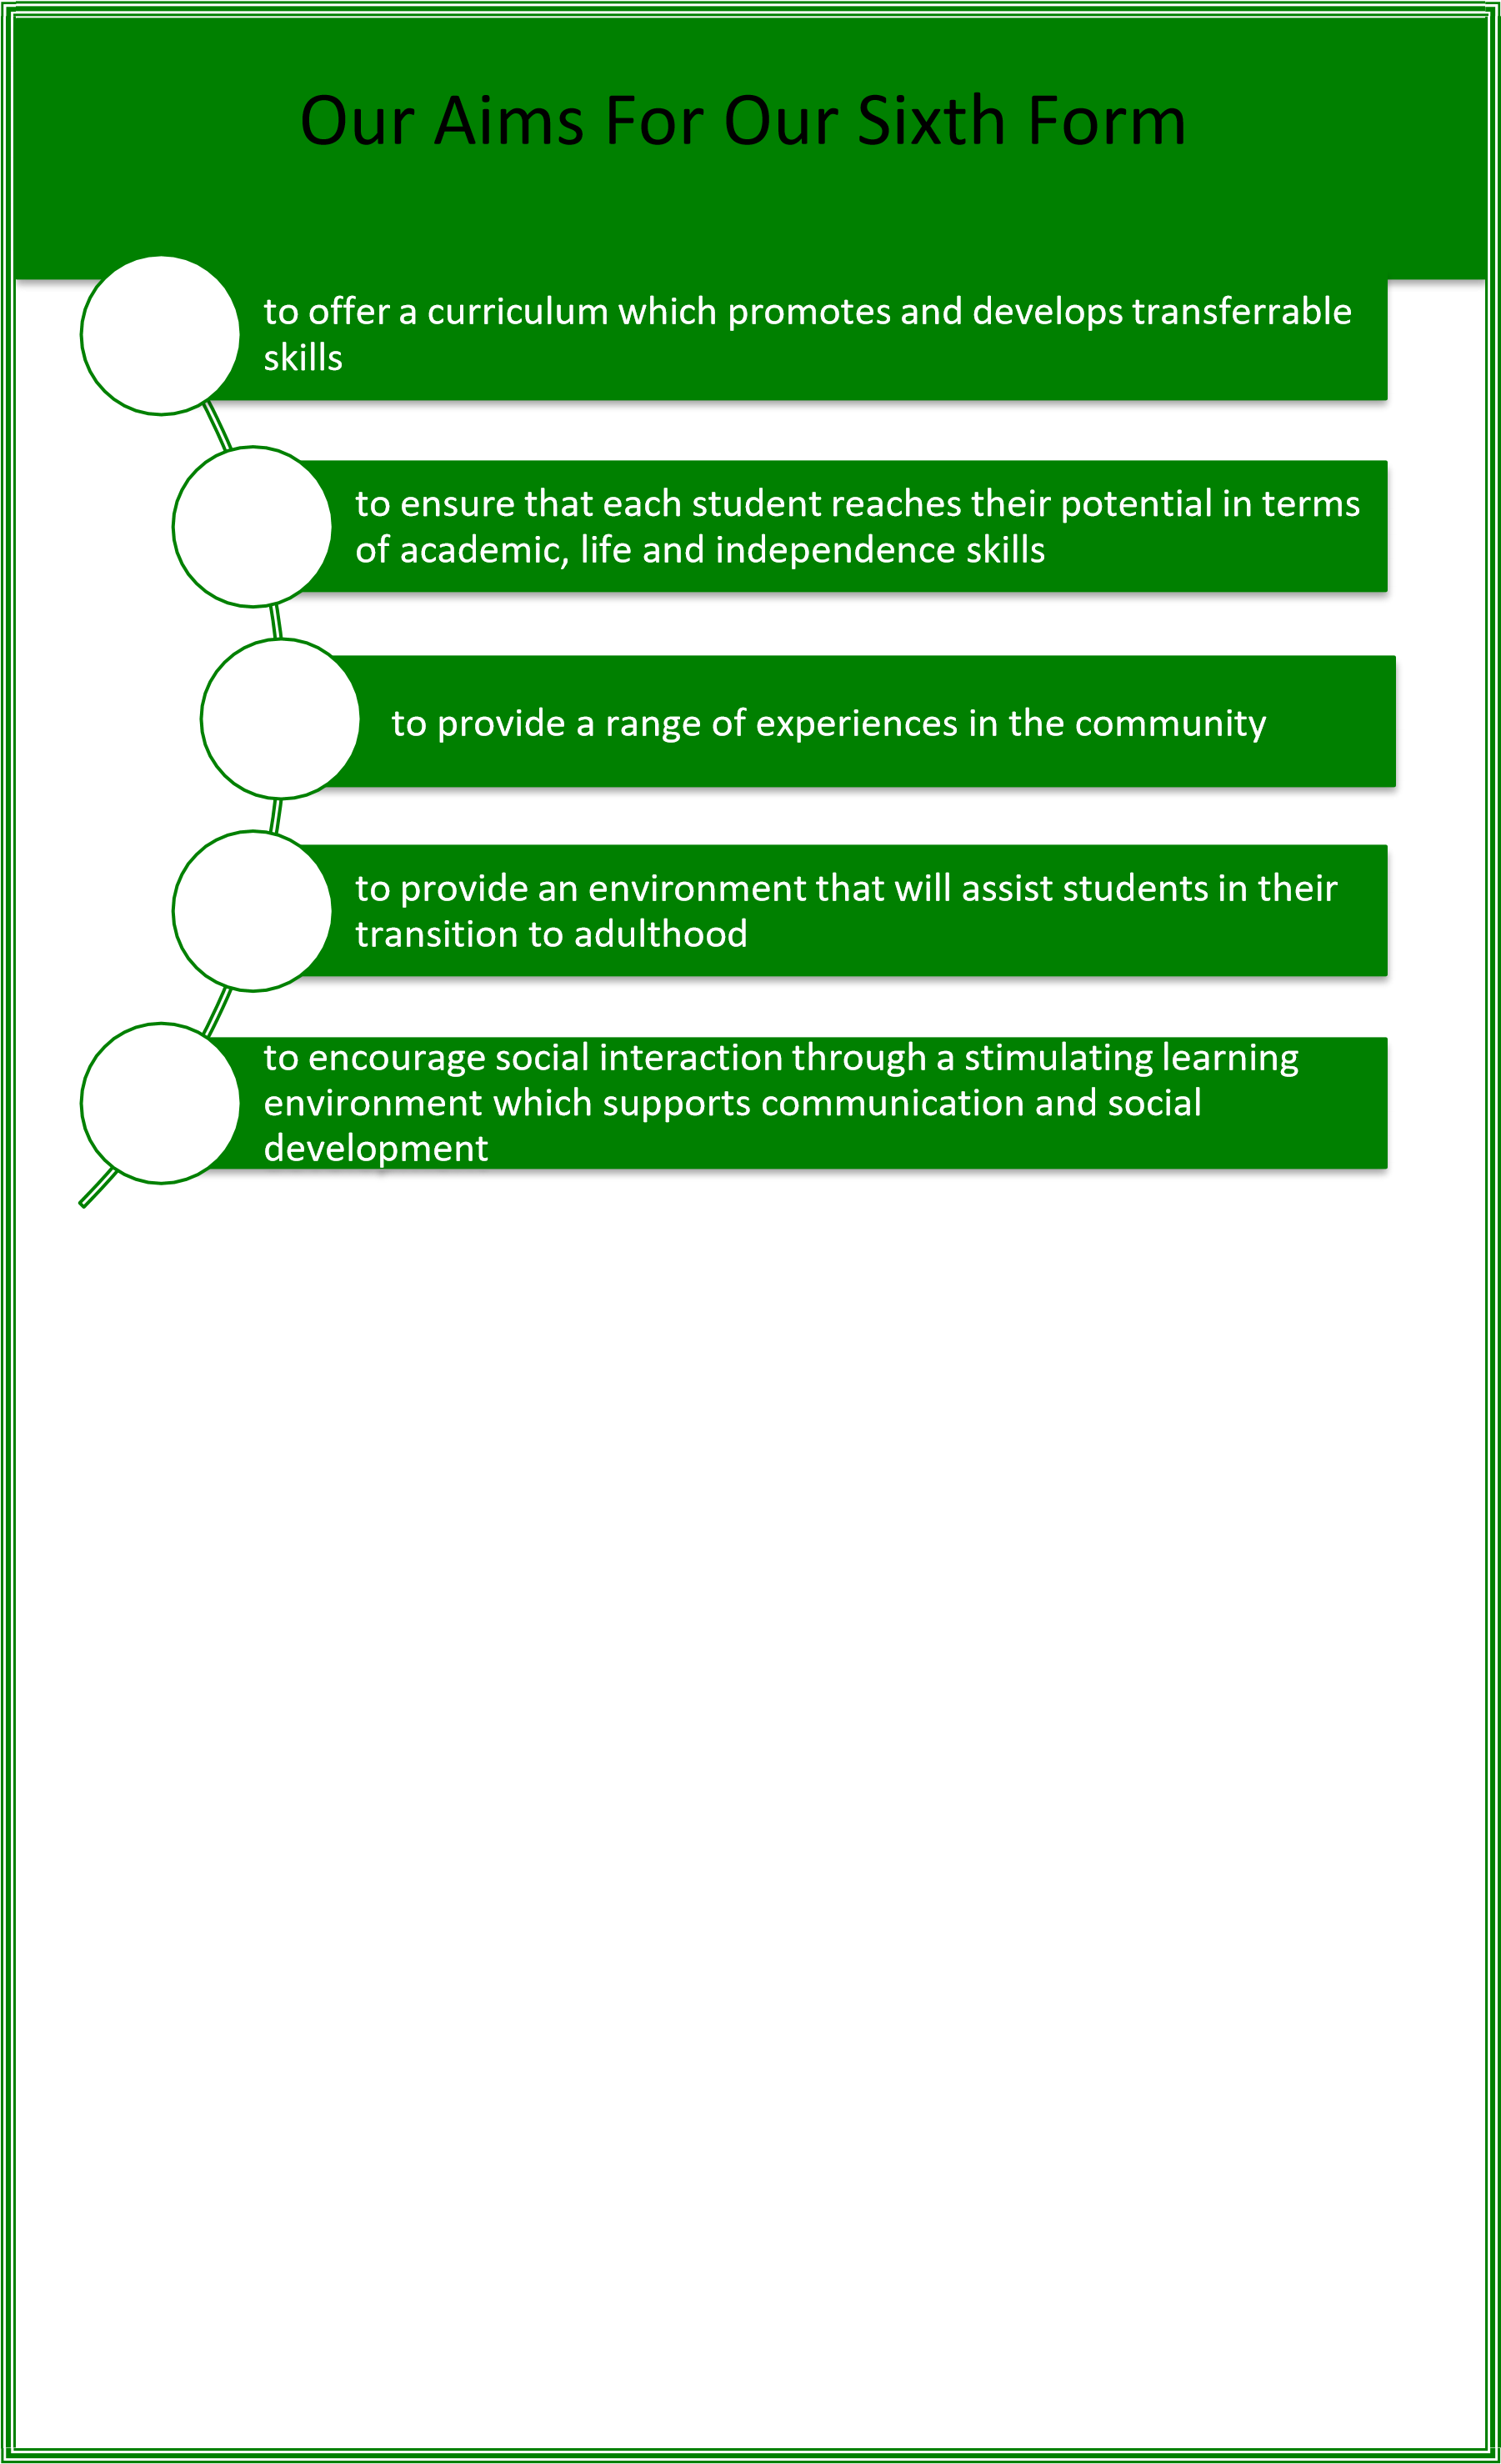

Curriculum Programmes

❖

OCR Life and Living Skills

❖

Functional Skills Maths

❖

Functional Skills English

❖

Independence Skills including shopping, developing travel
Training and leisure activities
❖

Work experience

❖

❖

National Curriculum Subjects

Educational Visits
Enterprise

- We aim to promote independence at an appropriate level through our selected programmes. Our programmes develop everyday skills including independent living and travel training skills.

- Through our Hospitality and Retail Pathway we aim to develop the business minds of our Sixth Form, developing skills such as producing and selling products, managing finances and monitoring outgoings and profits.

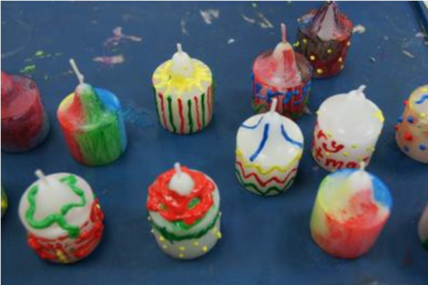

Pathways

Food Technology and Café.

Animal
Care

Horticulture

Art
Pathways

Drama

Hospitality and Retail

Sports

Pathways

- Our Pathways programme provides our students with the opportunity to experience a range of vocational areas, supporting them to develop their skills, interests and aspirations.
- Students will work towards an accredited qualification based on the Pathway that they are on.

- Pathways are carried out on Tuesday and Thursday afternoons.
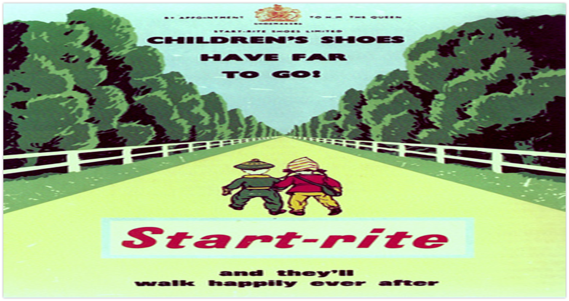

Other Subjects

Along with all of these accredited subjects, sixth form continue to study Computing, Food Tech, PE and PSHE These subjects follow the school’s tailored curriculum and are assessed according to our curriculum ladders which are available on our website.

https://www.oaktree.enfield.sch.uk/page/?title=Curriculum&pid=25

Work Experience

There are opportunities for work experience at appropriate levels both on
and off site.

We aim to provide work experience for all of our students during their time in the Sixth Form.

Our in house job coach will provide our young adults with appropriate support and work experience opportunities as well as advice and help with college applications, cv’s, etc.

How To Contact US

Headteacher: Mr Russell Davey
Chair of Governors: Mrs Alex Bussandri
Head of Sixth Form/Careers Leader: Kyri Nicholas

Oaktree School
Chase Side
Southgate
London N14 4HN
Tel: 020 8440 3100 Fax: 020 8440 4891
email: info@oaktree.enfield.sch.uk
Website: http://www.oaktree.enfield.sch.uk

To contact us please telephone the main office on 0208 440 3100 and choose the department you wish to speak to. If the department is not listed, please press 0 and speak to Ruth.

